Spider-Man

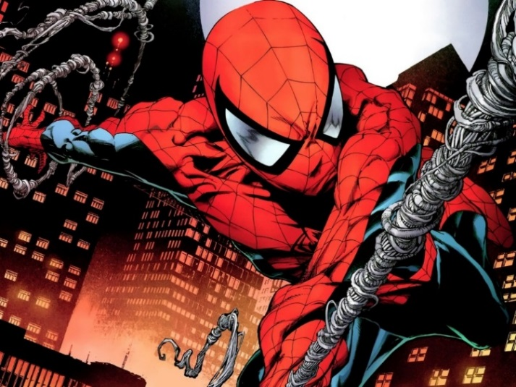
Real Name: Peter Parker

Occupation: scientist and inventor; former freelance photographer, assistant high school coach, science teacher

Height: 5 ft. 10 in.

Weight: 165 lbs.
Powers

Spider Physiology: Spider-Man possesses the proportionate powers of a spider, granted to him from an irradiated common house spider, which bit Peter Parker that was apparently already mutated from prior exposure to certain frequencies of radiation

Wall Crawling: Due to his exposure to the mutated spider venom, Peter can cling to most surfaces like a spider.

Superhuman Strength: Spider-Man possesses superhuman strength enabling him to press lift many tons. Originally, Spider-Man could lift ten tons. After Queen's mutation, he could lift 15 tons. Finally, after the Other evolution, he can lift 20 tons. Spider-Man's physical strength is sufficient enough to enable him to lift and throw objects as heavy as a big rig semi-truck with ease.

Superhuman Speed: Spider-Man has showed to be fast enough to catch up to an accelerating car while on foot, but prefers to travel by webs.

Superhuman Stamina: At his peak, Spider-Man can physically exert himself at his peak capacity for several hours before the buildup of fatigue toxins in his blood begins to impair him. and is roughly 15 times more agile than a regular human.

Superhuman Reflexes: Spider-Man's reflexes are similarly enhanced and are currently about 40 times greater than those of an ordinary human. In combination with his spider-sense, the speed of his reflexes allows him to dodge almost any attack, or even gunfire, if he is far enough away. Spider-Man has even been shown in some cases, to be able to dodge gunfire using just his reflexes without his Spider-Sense.

Regenerative Healing Factor: Spider-Man has a limited healing factor. While not on Wolverine's level, it is sufficiently powerful enough to recover from severe injuries from broken bones and large amounts of tissue damage in a matter of days

Spider-Sense: Spider-Man possesses an extrasensory “danger” or “spider” sense which warns him of potential immediate danger by tingling sensation in the back of his skull. The precise nature of this sense is unknown. It appears to be a simultaneous clairvoyant response to a wide variety of phenomena (everything from falling safes to speeding bullets to thrown punches), which has given several hundredths of a second’s warning, which is sufficient time for his reflexes to allow him to avoid injury. The sense also can create a general response on the order of several minutes: he cannot discern the nature of the threat by the sensation. He can, however, discern the severity of the danger by the strength of his response to it. Spider-Man’s fighting style incorporates the advantage that his “spidey-sense” provides him.

Abilities:

Genius Intellect: Academically gifted, Peter displays an uncanny affinity for science that is nothing short of genius. According to Parker his IQ is north of 250. Some of the Earth's most brilliant minds, such as Reed Richards and Hank Pym have acknowledged Peter's intellect.

Skilled Inventor: Peter has been able to use his amazing intellect and resources at Horizon Labs to create many inventions such as the three Spider-Armors, the Spidey Stealth Suit, his famous webshooters, the Cyro-Cube 3000 and the noise reduction headphones. Recently, after his resurrection, he invented anti-Electro netting to try to depower Electro.

Master Acrobat: Thanks to his great strength and phenomenal equilibrium, Parker is an excellent athlete, excelling in all gymnastic fields and being able to perform every acrobatic stunt ever performed, including others that can never be performed by even an Olympic acrobat.
Master Hand-to-Hand Combatant: Due to his life being bullied and pranked as a young teenager, Parker has, through time, become an excellent hand-to-hand combatant, utilizing a fighting style that directly complements his superhuman abilities. His methods are volatile, enabling him to rival practically all types of combatants. Peter has been trained by Captain America in unarmed combat. As a means to compensate for the temporary loss of his spider-sense, Parker also received formal combat training from Shang-Chi through the recommendation of the new Madame Web (Julia Carpenter). Together, they created a new martial art style, the 'Way of the Spider' and Peter's skill with it has substantially increased following the return and amplification of his Spider-Sense. He is very skilled in his fighting style.

source: http://marvel.wikia.com/Spider-Man_(Peter_Parker)

