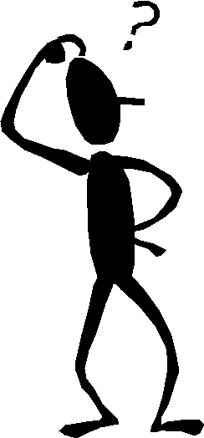
Demon Spelling-Commonly Confused Words 1

Use the guidebook to DEFINE each word AND fill in the blanks.
Do not forget to use Quizlet to review for the test.
https://quizlet.com/104915726/cvms-demon-spelling-commonly-confused-words-1-flash-cards/?new

(accept, except)

1. accept:

2. except:

3. What part of speech is the word “accept?” __________________________________

4. What part of speech is the word “except?” __________________________________

5. The store will ___________________________ donations for families this Christmas.

6. Everyone received his or her invitation __________________________ one person.

(affect, effect)

7. affect:

8. effect (if used as a NOUN):

9. The word affect is ALWAYS a ____________________________________.

10. Your attitude will _____________________________ your success.

11. The ________________________ of doing your homework is getting good grades.

12. Your tears do not ___________________________ me.

13. A flood was the _______________________________ of the thunderstorm.

(allowed, aloud)

14. allowed:

15. aloud:

16. We weren’t _________________________ to read __________________________ in the library.

17. If you read your essay _________________________, you will be able to find the mistakes.

(a lot, allot)

18. a lot:

19. allot:

20. A lot is NOT _________________________ word!

21. I like chocolate ________________________________.

22. My teacher _____________________________ my seat on the first day.

23. He was _____________________________ 10 minutes for his speech.

(board, bored)

24. board:

25. bored:

26. The school __________________________ makes some of our school rules.

27. I can’t imagine how anyone could be _________________________ in Core!

28. We used the _________________________ as a ramp for the four-wheeler.

29. The woodpecker ________________________ a hole right through the tree.

(brake, break)

30. brake:

31. break:

32. Use your _____________________ pedal when going down hill.

33. You should wear a helmet in case you need to __________________________ suddenly.

34. Don’t fall for her. She will _________________________ your heart.

(by, buy, bye)

35. by:

36. buy:

37: bye

38. When you walk _______________ the puppies at Wal-Mart, try not to ____________ one.

39. I want to _________________ all the books written _______________ my favorite author.

40. _________________! I’ll see you later.

(can, may)

41. can:

42: may:

43. I believe in you! You _________________ finish if you just try hard enough!

44. ________________ I go to the office to call my mom?

(capital, capitol)

45. capital:

46. capitol:

47. I have been to the ______________________ building in Salt Lake City.

48. It’s not a sentence if you forget to start it with a ______________________ letter!

49. We don’t have enough _____________________ to start our own business.

(does, dose)

50. does:

51. dose:

52. The doctor ordered the nurse to increase the patient’s _________________.

53. She ________________ belong to the technology club.

54. What _______________ he want to do on Friday?

55. What __________________ _________________ the prescription say?

